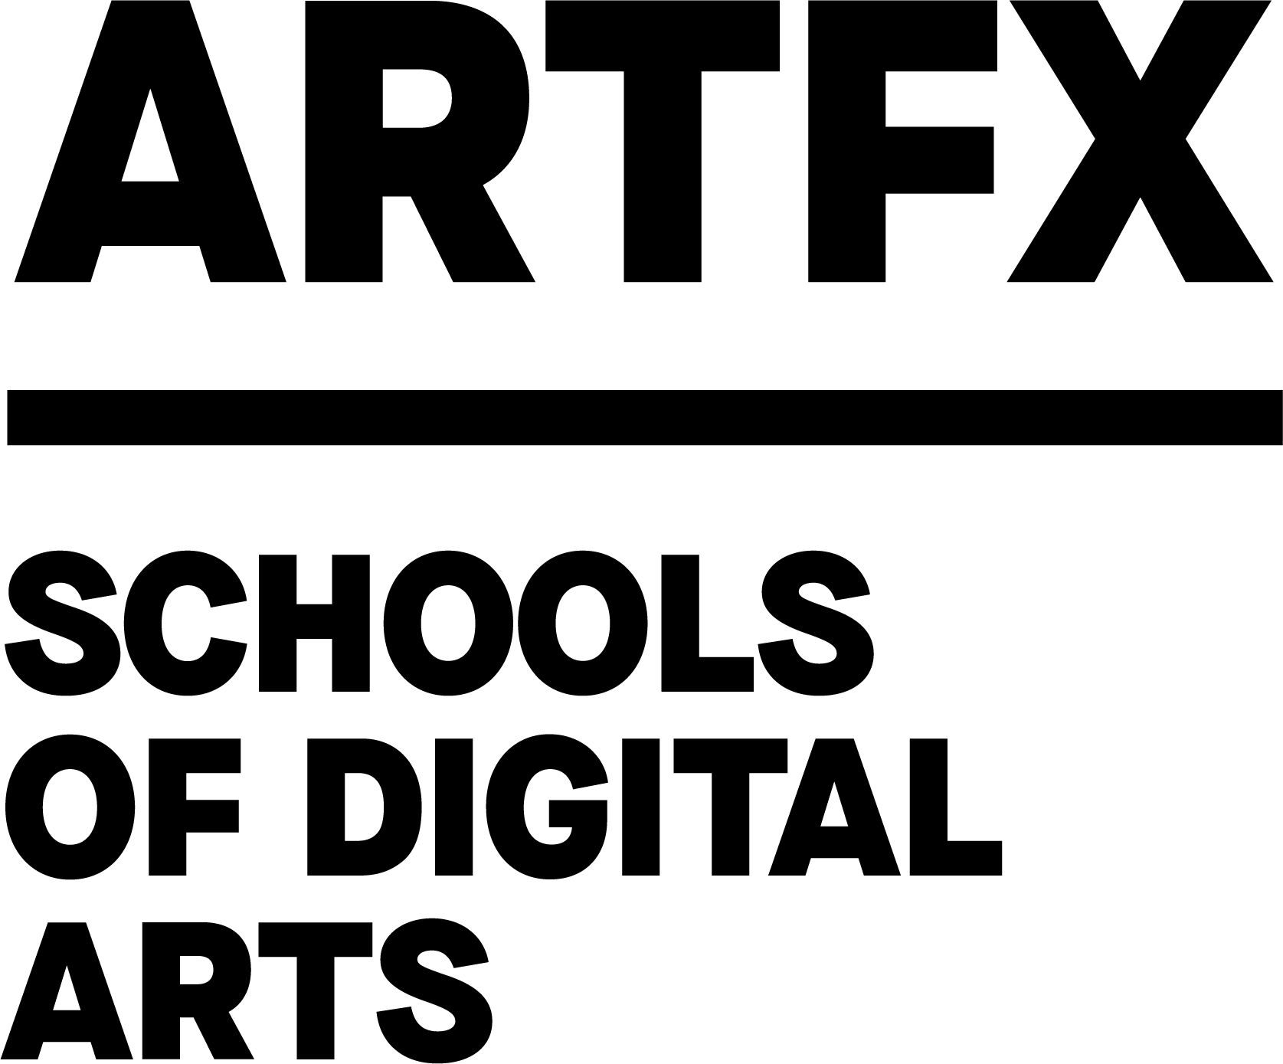
PRESS RELEASE
Montpellier
02/21/24

ARTFX shines in Los Angeles, winning
the most prestigious prize in special effects!

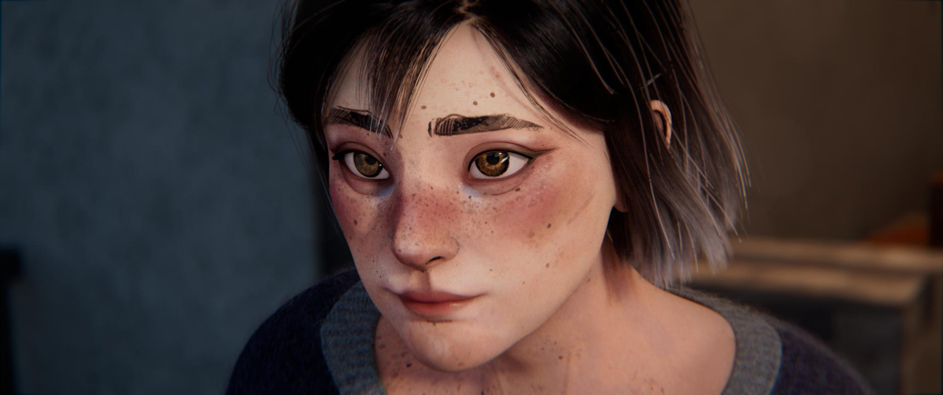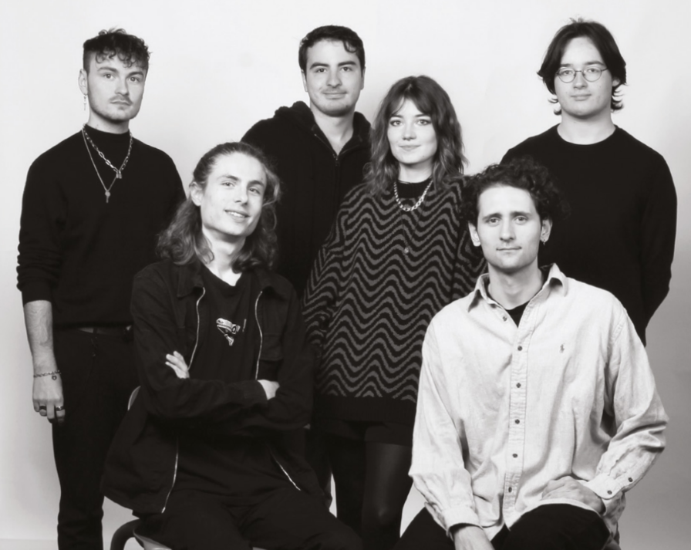

"SILHOUETTE" - produced by 6 ARTFX students from the Montpellier campus - wins Best Visual Effects for a student project at the VES Awards 2024!
wins Best Visual Effects for a student project at the VES Awards 2024!

On Wednesday 21 February 2024, at the 22nd Visual Effects Society gala evening in Los Angeles, the winners of the best visual effects of 2023 were announced. Among the most renowned international productions such as THE CREATOR, SPIDER-MAN: ACROSS THE SPIDER-VERSE and THE LAST OF US, a French film entitled "SILHOUETTE", produced by six students from ARTFX's Montpellier campus, was honoured with the prestigious VES Award in the "Outstanding Visual Effects in a Student Project" category. This marks the third time ARTFX has won this award, consolidating its position as a major reference on the international scene for film professionals. In 2023, the school was hailed for the 5th year running as the best in the world by independent jury The Rookies.
“Often compared to the Oscars of the visual effects industry, the VES Awards represent a real accolade for our six students. We are delighted with their success and warmly congratulate them on this well-deserved recognition! This is the third time that ARTFX films have been honoured in this way, which is a testament not only to the individual talent of our students, but also to the quality of the teaching provided by our instructors. As we prepare to celebrate 20 years of ARTFX this year, this achievement represents a wonderful gift in advance for our entire community. .” -Gilbert Kiner, founding chairman of ARTFX

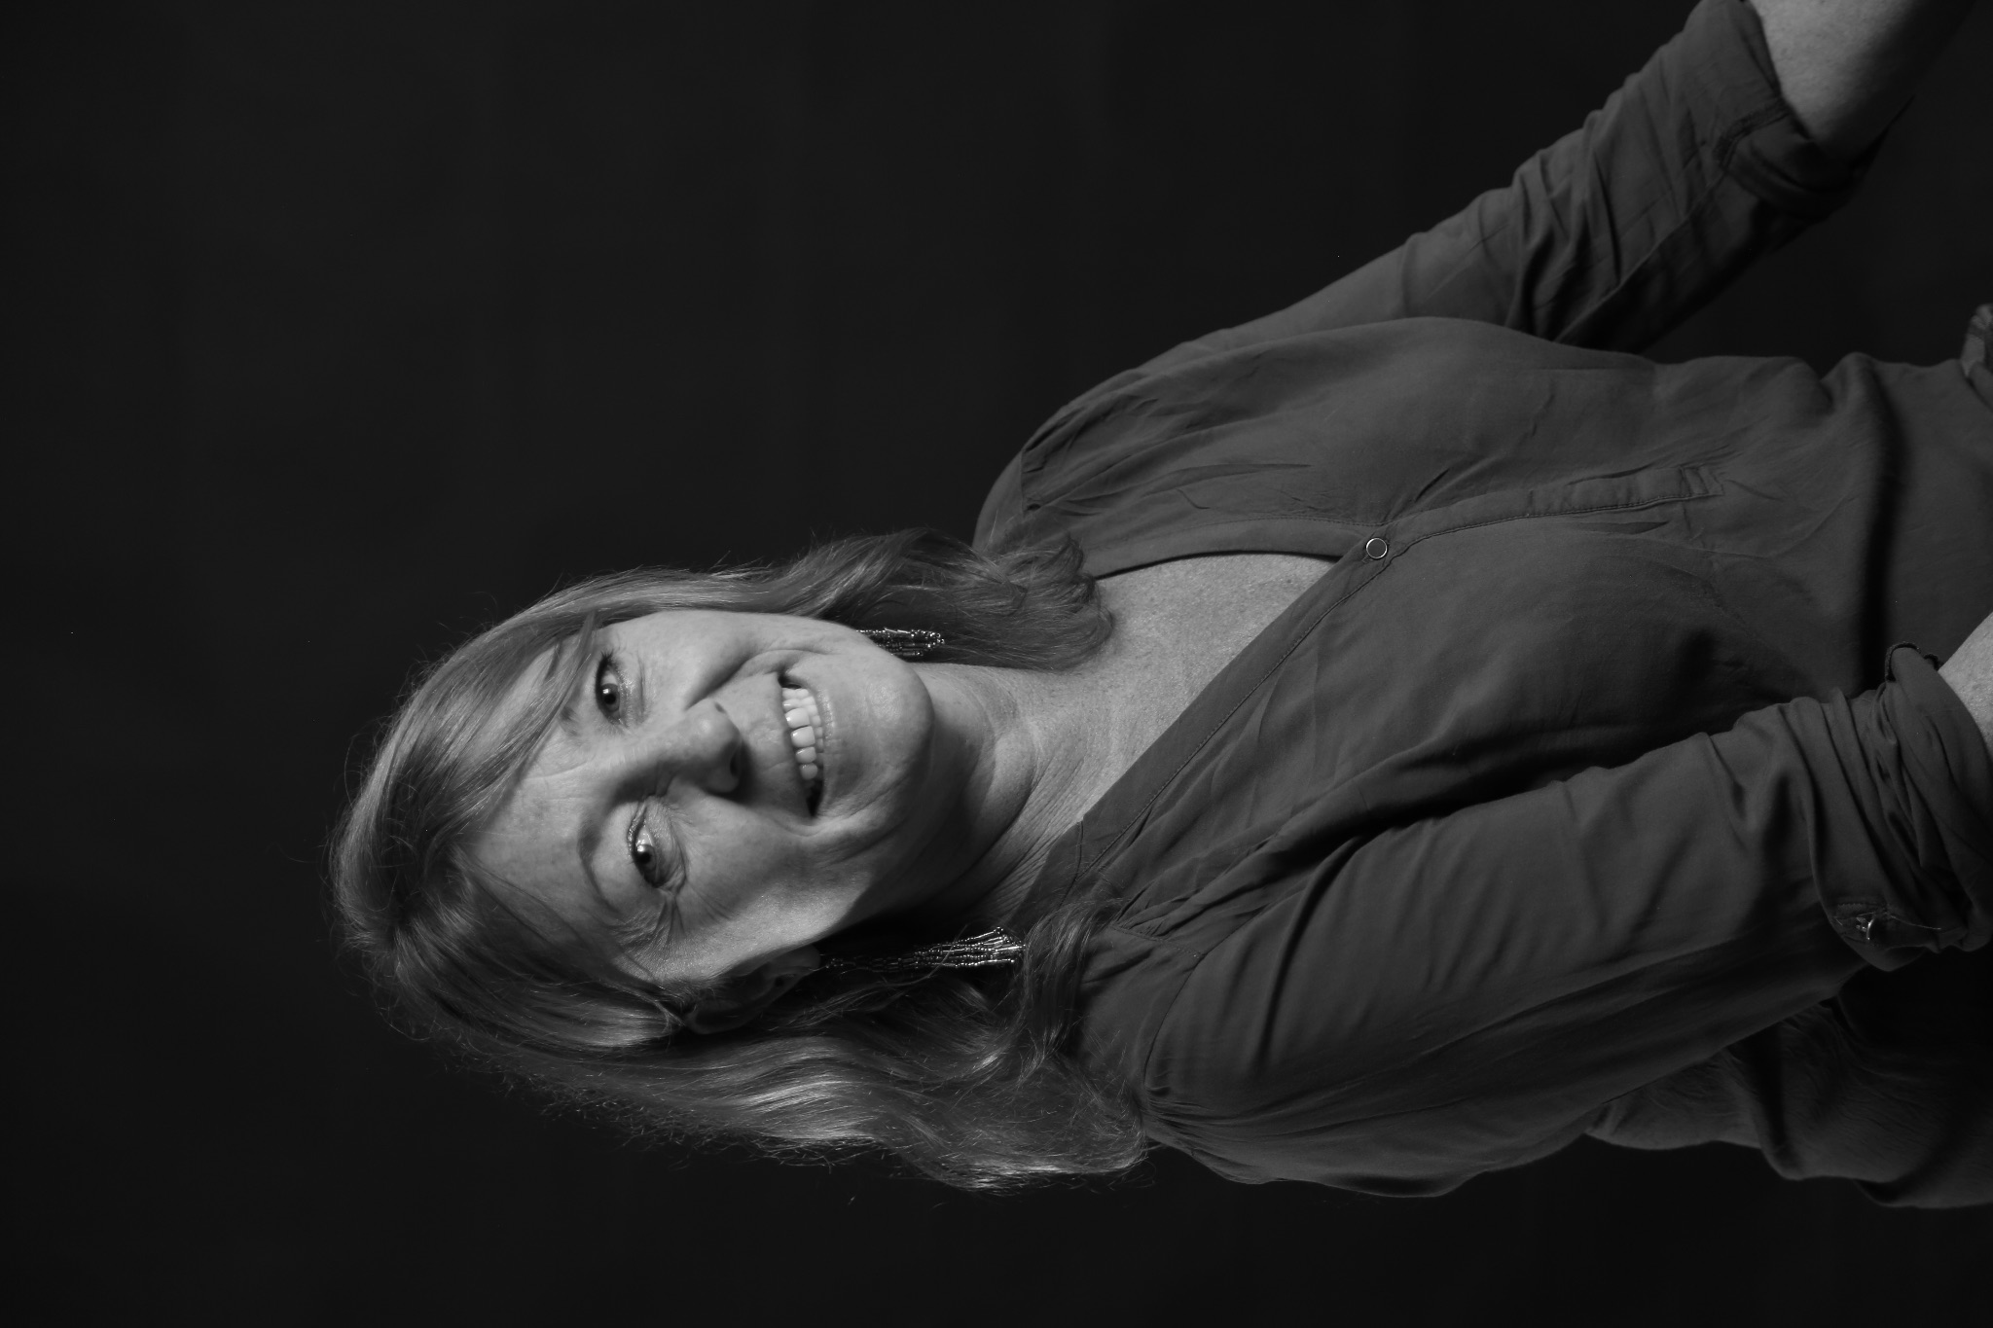
“This award is the most prestigious recognition given by industry professionals. Winning three of these awards in just five years is a magnificent affirmation of our school's position in the visual effects field. I'm extremely proud of this achievement, which testifies to how far our students and teaching staff have come! This film goes right to the heart of current social issues, but also makes excellent technical use of artificial intelligence. This achievement shows that our students are trained with passion and rigour, preparing them to work alongside some of the biggest names in the film industry..” -Dominique Peyronnet, Director of the Montpellier ARTFX campus

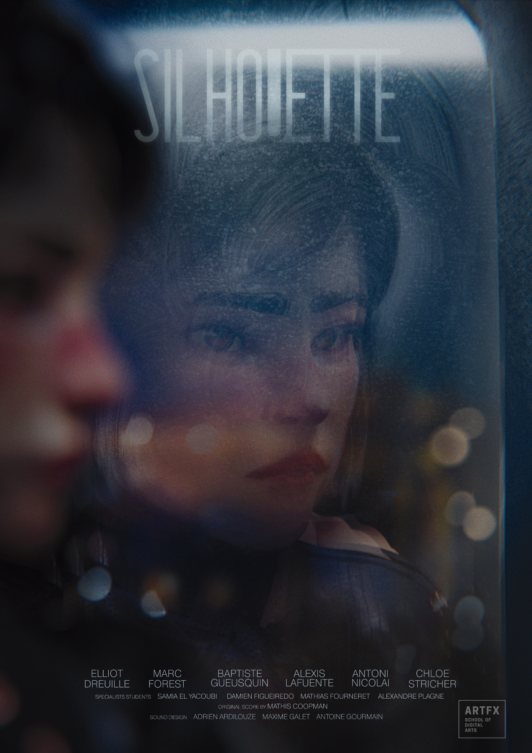
SILHOUETTE :

Silhouette tells the story of a young woman, Claire, who has just moved to a big city.
We follow her in this cold environment, where her body quickly disappears as a visual representation of her isolation and loneliness.

The production team: Chloé STRICHER, Alexis LAFUENTE, Antoni NICOLAI, Elliot DREUILLE, Baptiste GUEUSQUIN et MARC FOREST
Type : Full CGI
Techniques : 3D Animation, Camera Mapping, CGI, Compositing, Environment, CFX, Matte Painting, Artificial Intelligence, Character Modeling, Cloth Simulation, Groom, Rigging, 2D Animation, Digital Painting, Concept Art
Softwares : Maya, Houdini, V-Ray, Nuke, Photoshop, Substance Painter, Marvelous Designer, Blender, Zbrush, Ebsynth, Krita, Davinci Resolve

3 ARTFX films rewarded at the VES Awards!
"SILHOUETTE" is the 3rd ARTFX film to win a VES award, following Terra Nova in 2019 and Green in 2021. Since the creation of the VES Awards, 12 other films from the school have also been selected!

About ARTFX

ARTFX - Schools of Digital Arts are international graduate schools for cinema, special effects, animation and video games in Lille, Paris and Montpellier.
ARTFX was founded in 2004 by a team of passionate professionals. The management and teaching teams, made up of experts from the film, visual effects, animation and video game industries, maintain close relationships with the studios and are fully aware of their needs. ARTFX is one of the only schools not to belong to any group, so it remains free to make its own teaching choices and maintain its campuses on a human scale. A pioneering, independent school, ARTFX has 3 campuses in France and is celebrating its 20th anniversary in 2024!In 2023, ARTFX is recognised by The Rookies: 1st school in the SPECIAL EFFECTS category (for the 5th year running), 3rd school in the 3D ANIMATION category, 12th school in the world's top 50 ART SCHOOLS. ARTFX students' graduation projects are also regularly selected and rewarded by national and international festivals. In 2023, Alaska won Best Student Video Game at the Pegasus ceremony. Our students also won 3 VES Awards in 2019 (Terra Nova), 2022 (Green) and 2024 (Silhouette); and 3 Genie Awards for Best Student Film at the PIDS: Paris Images Digital Summit: in 2018 (The Endless), 2021 (Time's down) and 2022 (Green).

The school has been awarded the France 2030 "la grande fabrique de l'image" label, a government call for projects designed to put France at the forefront of the cultural and creative industries internationally. This support provides real backing for the ARTFX school and contributes to the strategic growth of the school at its three sites: Montpellier, Lille and Enghien-les-Bains, with the development of new training equipment (film sets, technical areas) and more advanced training in emerging professions.

LINKS & SOCIAL MEDIA
- ARTFX website: https://artfx.school/en/
- LinkedIn : https://fr.linkedin.com/school/artfxschool
- Facebook : https://www.facebook.com/ARTFX/
- Instagram : https://www.instagram.com/artfxschool/
- Youtube : https://www.youtube.com/channel/UC9U6wse8pvcKULtaAC6OBpg
- X / Twitter : https://twitter.com/artfxschool
- Itch.io : https://artfx-school.itch.io/

INFO & CONTACTS
ARTFX Montpellier
95 rue de la Galéra, 34090 Montpellier (FRANCE)
+334 997 701 42
Campus Director : Dominique Peyronnet dpeyronnet@artfx.fr
Direction Générale d’ARTFX
Simon Vanesse - Chief Executive Officer of ARTFX
Romain Klapka - Director of Communications
communication@artfx.fr

Mot Compte Double Agency
Vanessa GELLIBERT – +336 800 604 16 – vgellibert@motcomptedouble.fr
Eva DELABARRE – 06 07 75 39 89 – edelabarre@motcomptedouble.fr

